PROJECT REPORT

ABSTRACT

A blind assistance project aims to provide support and aid to individuals with visual impairments, helping them navigate and interact with their environment more effectively. We would wish to make an Integrated Machine Learning System that allows the blind victims to identify and classify real time objects generating voice feedback which also produces warnings whether they are very close or far away from the victim. We also wish to guide the blind person with directions to help him/her navigate the path.

SEGMENTATION

Image segmentation is a fundamental task in computer vision that involves dividing an image into distinct regions or segments based on certain criteria or characteristics. The primary goal of image segmentation is to partition an image into meaningful and semantically coherent regions, making it easier to analyze and understand the visual content within the image. Three types of segmentation are:-

1. INSTANCE SEGMENTATION
2. SEMANTIC SEGMENTATION
3. PANOPTIC SEGMENTATION

A) INSTANCE SEGMENTATION

Instance segmentation is a computer vision task that combines various fundamental tasks in the field of computer vision. It involves identifying and delineating individual objects within an image while also classifying them into different object categories. In other words, instance segmentation goes beyond the scope of semantic segmentation, which only assigns a class label to each pixel in an image, and it provides a unique identifier for each object instance present in the image.

The crucial step in instance segmentation is distinguishing between individual instances of the same class. Each segmented object is assigned a unique identifier or label, so the algorithm can differentiate between multiple instances of the same class. For example, if there are two cars in the image, instance segmentation ensures that they are assigned separate identifiers.

For performing Instance Segmentation we have used various models as listed below:-

1. Mask R-CNN
2. YoloV8
3. Detectron 2
4. FastSAM

Turning upon the models one by one let’s see about their functioning and tasks performed:-

A) Mask R-CNN

Mask R-CNN is an instant segmentation algorithm which means that it can detect the object in the image but also a mask on each object. This means that on a person you not only have the box but the coordinates surrounding the person. Mask R-CNN was developed in 2017, which means that it is old, in computer vision software development is very fast, but still today it is an excellent algorithm to be used even in commercial projects.

Architecture of Mask R-CNN

Mask R-CNN has the following components:-

1. Backbone Network: Mask R-CNN typically uses a standard convolutional neural network (CNN) as its backbone. Common choices include ResNet, ResNeXt, or Feature Pyramid Network (FPN) backbones. The backbone network extracts feature maps from the input image, progressively reducing spatial dimensions while increasing the number of channels.
2. Region Proposal Network (RPN): Similar to Faster R-CNN, Mask R-CNN includes an RPN that operates on the feature maps produced by the backbone network. The RPN generates region proposals, which are candidate bounding boxes for objects in the image. These proposals are used for both object detection and mask prediction.
3. RoI Align: RoI (Region of Interest) Align is a critical component that allows Mask R-CNN to perform precise pixel-level segmentation. It takes the feature maps and the region proposals generated by the RPN and aligns the extracted features with a fixed-size grid, ensuring that pixel-level details are preserved during the subsequent processing.
4. Object Detection Branch: Mask R-CNN includes a branch for object detection similar to Faster R-CNN. This branch predicts class labels and bounding box offsets for each region proposal. This part of the network identifies objects and their positions within the image.
5. Mask Prediction Branch: The key innovation of Mask R-CNN is its mask prediction branch. After the object detection branch, the network has an additional branch that predicts pixel-wise masks for each detected object. This branch is typically implemented as a series of convolutional layers followed by a sigmoid activation function for each class. Each class predicts a binary mask (foreground/background) for each object instance.
6. Loss Functions: Mask R-CNN uses multiple loss functions to train the network effectively. These include: Bounding Box Loss: This loss function measures the accuracy of bounding box predictions. Classification Loss: This measures the accuracy of class predictions. Mask Loss is this loss function evaluates the quality of the pixel-wise mask predictions.
7. Post-processing: After training, the network produces bounding boxes, class labels, and pixel-wise masks for each detected object. Post-processing steps are often applied to refine and filter the results, such as non-maximum suppression (NMS) to remove redundant bounding boxes.

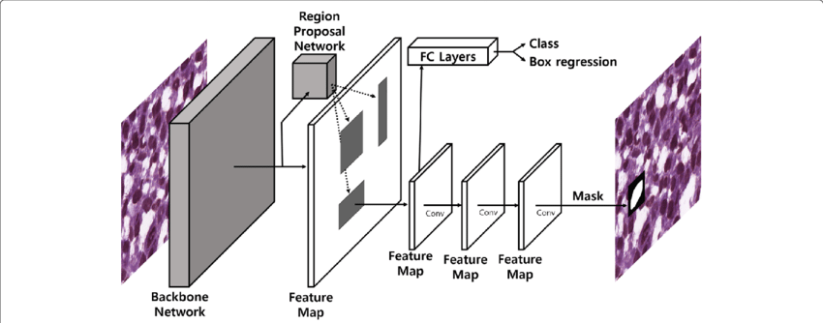

DATASETS

COCO is one of the most widely used datasets for object detection and instance segmentation. It contains a large collection of images spanning 80 different object categories. The dataset includes over 200,000 labeled objects within more than 120,000 images, making it valuable for training and benchmarking instance segmentation models like Mask R-CNN. Here is some key information about the COCO dataset:-

1. Dataset Overview: COCO was created by Microsoft Research in collaboration with several academic institutions. It was introduced to address the need for a comprehensive dataset that covers a wide range of object categories and provides fine-grained annotations. The dataset contains images captured in complex scenes, both indoor and outdoor, under various lighting and environmental conditions.
2. Object Categories: COCO includes a total of 80 object categories, making it suitable for multi-object detection and segmentation tasks. These categories cover a broad spectrum of common objects, including animals, vehicles, furniture, and more.
3. Data Split: The COCO dataset is divided into three main subsets: train, validation, and test. The train and validation splits are the most commonly used for training and evaluating computer vision models. The train split consists of approximately 118,000 images with detailed annotations. The validation split includes about 5,000 images, and the test split, used for evaluation purposes, contains approximately 41,000 images.
4. Annotations: COCO is known for its extensive and precise annotations. Each image in the dataset is annotated with: Object bounding boxes: These specify the location and size of each object instance in the image.
5. Object labels: These indicate the category of each object. Object segmentation masks: These provide pixel-level masks for each object instance, enabling instance segmentation tasks. Captions: In addition to object-level annotations, COCO includes five human-generated captions for each image, making it suitable for image captioning tasks.
6. Challenges: COCO has hosted several challenges and competitions, such as the COCO Object Detection Challenge, COCO Captioning Challenge, and more. These challenges have spurred advancements in computer vision research and led to the development of state-of-the-art models.
7. Usage: COCO has become a benchmark dataset for evaluating the performance of object detection, instance segmentation, and image captioning models. Many research papers and models report their results on the COCO dataset, allowing for fair comparisons between different approaches. It has played a significant role in advancing the field of computer vision, particularly in tasks related to scene understanding and object recognition.
8. Availability: The COCO dataset is publicly available for research purposes. You can access the dataset, annotations, and evaluation tools from the official COCO website: COCO Dataset. Overall, the COCO dataset has had a substantial impact on computer vision research by providing a large-scale and well-annotated dataset for various tasks, enabling the development of more accurate and robust computer vision models.

LIBRARIES USED

1. COCO API: The official COCO API is the most direct and recommended way to work with the COCO dataset. It provides Python functions and classes to load images, annotations, and captions from the dataset. You can install the COCO API using pip: bash Copy code pip install pycocotools Example GitHub repository with code and documentation: COCO API GitHub
2. OpenCV: OpenCV is a popular computer vision library that can be used for reading and processing images from the COCO dataset. You can use OpenCV to load images, display them, and perform various image processing tasks. Installation: pip install opencv-python Matplotlib:
3. Matplotlib is a widely used library for creating visualizations and plots. It's helpful for visualizing images and annotations from the COCO dataset. Installation: pip install matplotlib NumPy:
4. NumPy is a fundamental library for numerical operations in Python. It's often used in conjunction with other libraries to manipulate and process data from COCO. Installation: pip install numpy
5. Pandas: If you're working with tabular data extracted from COCO annotations, Pandas can be useful for data analysis and manipulation. Installation: pip install pandas
6. TensorFlow or PyTorch: If you plan to build deep learning models, you may use TensorFlow or PyTorch as your deep learning framework. These libraries provide tools for training and evaluating object detection or instance segmentation models on COCO.
7. Scikit-image: Scikit-image is an image processing library that can be handy for various image-related tasks, such as preprocessing or augmenting COCO dataset images. Installation: pip install scikit-image

RESULTS

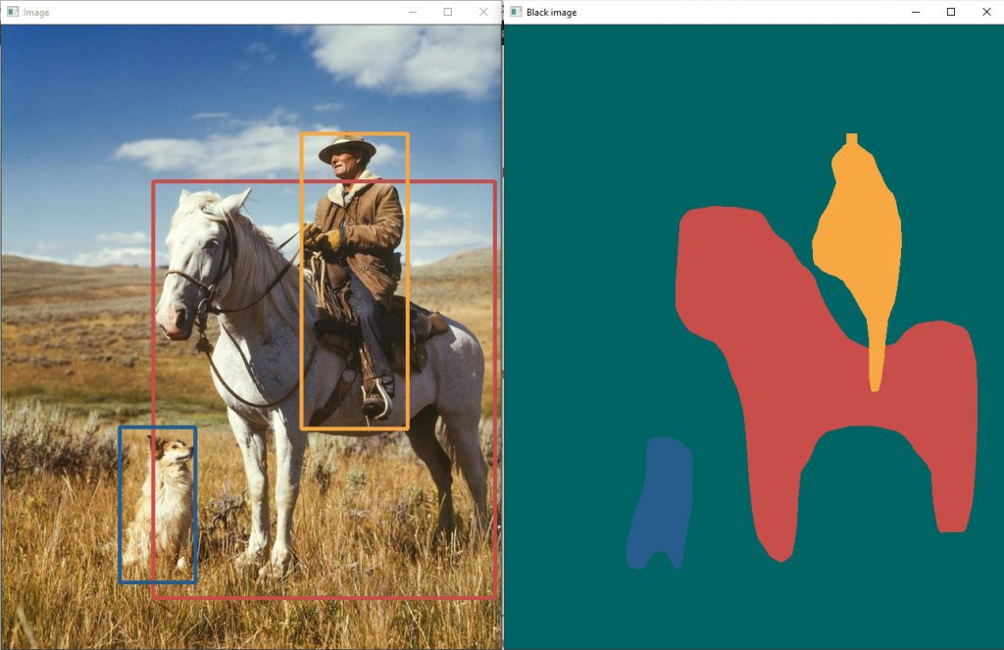

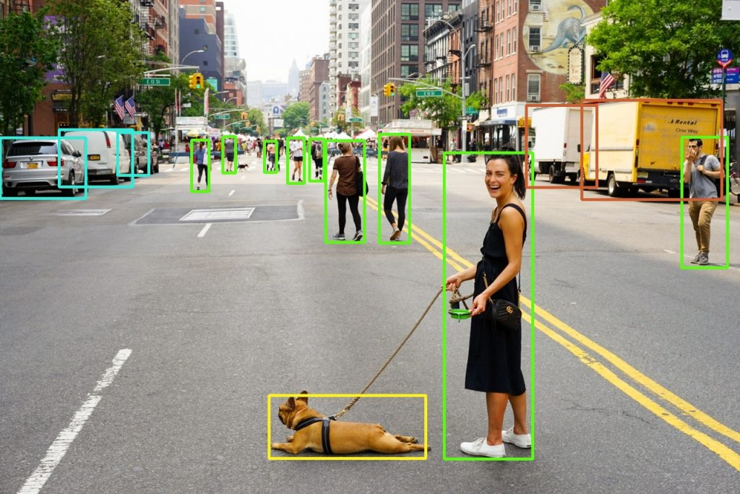

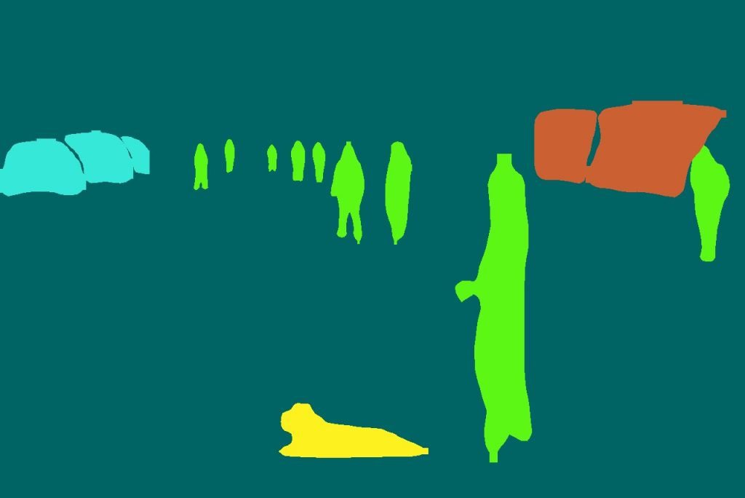

ACCURACY

PRE TRAINED MODEL

B) FastSAM

FastSAM is designed to address the limitations of the Segment Anything Model (SAM), a heavy Transformer model with substantial computational resource requirements. The FastSAM decouples the segment anything task into two sequential stages: all-instance segmentation and prompt-guided selection. The first stage uses YOLOv8-seg to produce the segmentation masks of all instances in the image. In the second stage, it outputs the region-of-interest corresponding to the prompt.

ARCHITECTUTRE

For the first part, instead of the heavy Visual Transformer architecture the authors utilize Yolov8-seg Yoloact architecture with a Yolov8 backbone) . The model was trained to predict only a single class instance segmentation masks, so it can generalize to any object type by design (this task is usually called salient object segmentation). Moreover, this single-class instance segmentation model was trained with two percent of the SA-1B dataset. Switching to CNN-based model makes image encoder significantly faster while usage of. The objects found by the class-agnostic instance segmentation model along with the text descriptions of the objects searched for are passed to the CLIP image and text encoder respectively. Finally, we match the objects and descriptions by their embedding similarity. Point prompts or box prompts can be used in this process. In this case, during the post-processing step, the algorithm selects masks that contain prompt points and masks that have intersections with prompt boxes.

The flow diagram below represents how things are carried out in this model:-

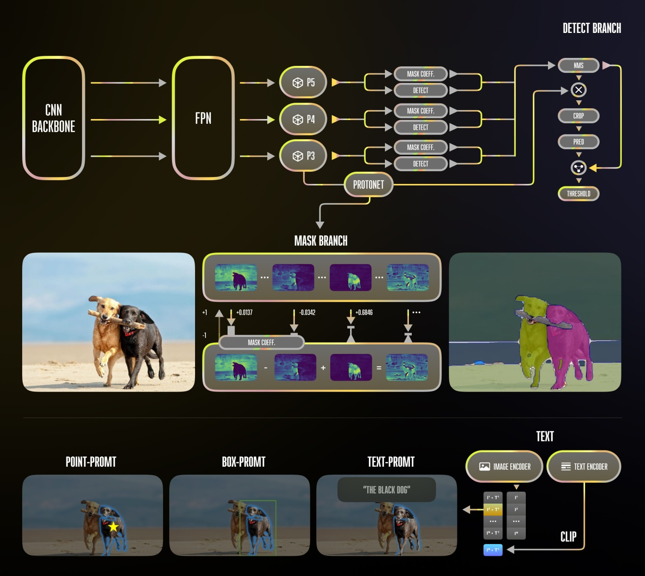

DATASETS

COCO is one of the most widely used datasets for object detection and instance segmentation. It contains a large collection of images spanning 80 different object categories. The dataset includes over 200,000 labeled objects within more than 120,000 images, making it valuable for training and benchmarking instance segmentation models like Mask R-CNN. Here is some key information about the COCO dataset:-

1. Dataset Overview: COCO was created by Microsoft Research in collaboration with several academic institutions. It was introduced to address the need for a comprehensive dataset that covers a wide range of object categories and provides fine-grained annotations. The dataset contains images captured in complex scenes, both indoor and outdoor, under various lighting and environmental conditions.
2. Object Categories: COCO includes a total of 80 object categories, making it suitable for multi-object detection and segmentation tasks. These categories cover a broad spectrum of common objects, including animals, vehicles, furniture, and more.
3. Data Split: The COCO dataset is divided into three main subsets: train, validation, and test. The train and validation splits are the most commonly used for training and evaluating computer vision models. The train split consists of approximately 118,000 images with detailed annotations. The validation split includes about 5,000 images, and the test split, used for evaluation purposes, contains approximately 41,000 images.
4. Annotations: COCO is known for its extensive and precise annotations. Each image in the dataset is annotated with: Object bounding boxes: These specify the location and size of each object instance in the image.
5. Object labels: These indicate the category of each object. Object segmentation masks: These provide pixel-level masks for each object instance, enabling instance segmentation tasks. Captions: In addition to object-level annotations, COCO includes five human-generated captions for each image, making it suitable for image captioning tasks.
6. Challenges: COCO has hosted several challenges and competitions, such as the COCO Object Detection Challenge, COCO Captioning Challenge, and more. These challenges have spurred advancements in computer vision research and led to the development of state-of-the-art models.
7. Usage: COCO has become a benchmark dataset for evaluating the performance of object detection, instance segmentation, and image captioning models. Many research papers and models report their results on the COCO dataset, allowing for fair comparisons between different approaches. It has played a significant role in advancing the field of computer vision, particularly in tasks related to scene understanding and object recognition.
8. Availability: The COCO dataset is publicly available for research purposes. You can access the dataset, annotations, and evaluation tools from the official COCO website: COCO Dataset. Overall, the COCO dataset has had a substantial impact on computer vision research by providing a large-scale and well-annotated dataset for various tasks, enabling the development of more accurate and robust computer vision models.

LIBRARIES USED

1. COCO API: The official COCO API is the most direct and recommended way to work with the COCO dataset. It provides Python functions and classes to load images, annotations, and captions from the dataset. You can install the COCO API using pip: bash Copy code pip install pycocotools Example GitHub repository with code and documentation: COCO API GitHub
2. OpenCV: OpenCV is a popular computer vision library that can be used for reading and processing images from the COCO dataset. You can use OpenCV to load images, display them, and perform various image processing tasks. Installation: pip install opencv-python Matplotlib:
3. Matplotlib is a widely used library for creating visualizations and plots. It's helpful for visualizing images and annotations from the COCO dataset. Installation: pip install matplotlib NumPy:
4. NumPy is a fundamental library for numerical operations in Python. It's often used in conjunction with other libraries to manipulate and process data from COCO. Installation: pip install numpy
5. Pandas: If you're working with tabular data extracted from COCO annotations, Pandas can be useful for data analysis and manipulation. Installation: pip install pandas
6. TensorFlow or PyTorch: If you plan to build deep learning models, you may use TensorFlow or PyTorch as your deep learning framework. These libraries provide tools for training and evaluating object detection or instance segmentation models on COCO.
7. Scikit-image: Scikit-image is an image processing library that can be handy for various image-related tasks, such as preprocessing or augmenting COCO dataset images. Installation: pip install scikit-image

RESULTS

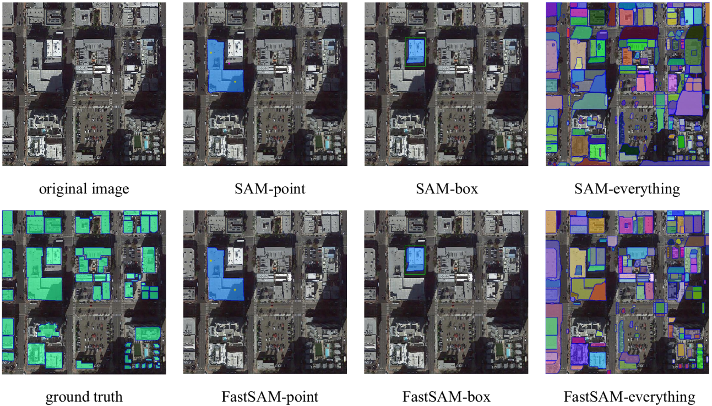

ACCURACY

(c) YOLO V8

ARCHITECTURE

YOLOv8 retains the core principles of YOLO, which involve dividing an input image into a grid and predicting bounding boxes, class probabilities, and objectness scores for objects within each grid cell. The key features of YOLOv8 include:

1. **Multi-Backbone Approach:** YOLOv8 often employs a multi-backbone approach, meaning it combines features from multiple backbone networks. This allows the model to capture both low-level and high-level features, enhancing its ability to detect objects of various sizes and complexities.
2. **Backbone Networks:** YOLOv8 typically uses well-known backbone architectures like CSPDarknet53 or CSPResNext50, which provide feature extraction capabilities. These backbones are responsible for processing the input image and extracting relevant feature maps.
3. **Multi-Scale Detection:**Similar to YOLOv3, YOLOv8 often incorporates multiple detection heads at different scales in the network. This enables the model to detect objects at various sizes and locations within the input image, improving detection accuracy.
4. **Anchor Boxes:** Anchor boxes are utilized for predicting bounding boxes with varying aspect ratios and scales. Each anchor box is associated with specific convolutional layers in the network to adapt to different object sizes.
5. **Objectness Score:** YOLOv8 predicts an objectness score for each bounding box. This score represents the model's confidence that there is an object within the box.
6. **Class Prediction:** For each detected object, YOLOv8 predicts class probabilities across the available classes. The number of classes depends on your specific dataset and task.
7. **Non-Maximum Suppression (NMS):** After making predictions, YOLOv8 often applies non-maximum suppression to filter out redundant bounding boxes, retaining the ones with the highest confidence scores. This reduces the number of overlapping detections.
8. **Efficiency:** YOLOv8 aims to strike a balance between accuracy and real-time inference speed, making it suitable for applications like autonomous vehicles, surveillance systems, and robotics.
9. **Backbone Variations:** YOLOv8 may have different versions, such as YOLOv8-S, YOLOv8-M, YOLOv8-L, which vary in terms of model complexity and computational requirements. These variations allow you to choose the one that best suits your hardware and performance needs.

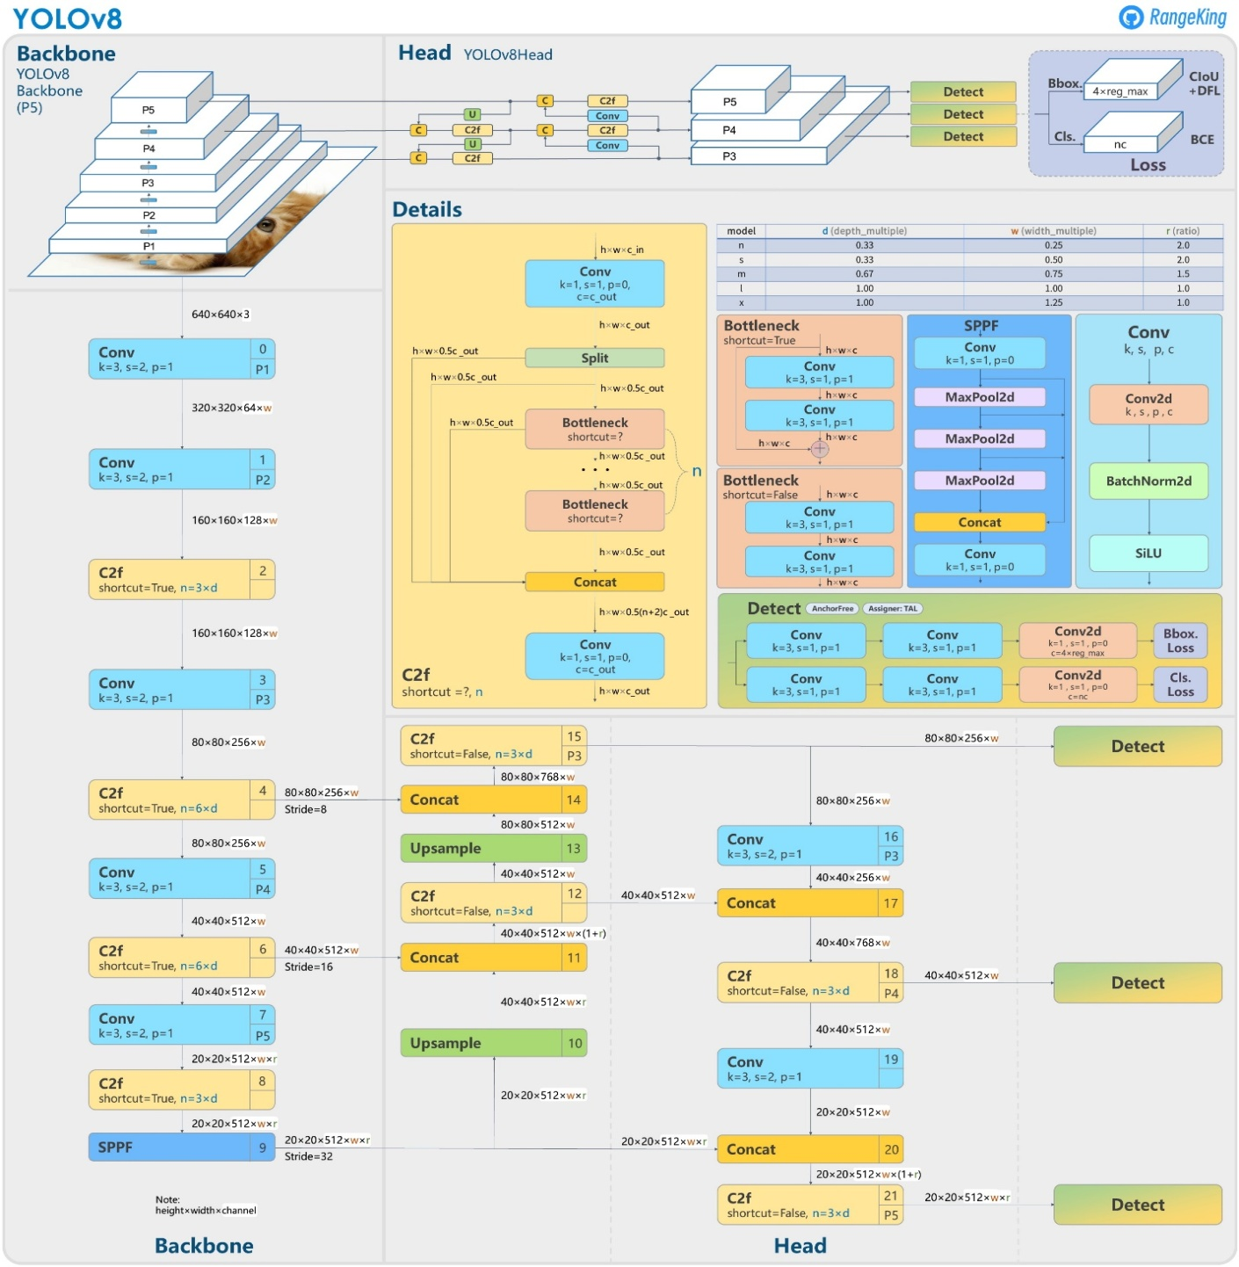

DATASET

The Common Objects in Context (COCO) dataset is a highly influential computer vision dataset comprising diverse images from everyday scenes and 80 object categories, providing rich annotations such as object bounding boxes, class labels, instance segmentation masks, and keypoints. Widely used for training and evaluating models in object detection, instance segmentation, keypoint detection, and image captioning, COCO has spurred advancements in computer vision, supporting challenges and competitions. Its impact on the field, diverse content, and permissive licensing make it a pivotal resource for researchers and developers in scene understanding and object recognition.

LIBRARIES USED

PyTorch or TensorFlow: These are the primary deep learning frameworks used for implementing YOLO-based models.

Ultralytics: It is a library that simplifies the training, evaluation, and deployment of YOLO-based models, particularly YOLOv5. It provides a user-friendly interface for working with these models.

OpenCV: Used for loading and preprocessing images, including tasks like resizing, normalization, and data augmentation.

NumPy: Often used for numerical operations and data manipulation.

Matplotlib: Useful for creating plots and visualizations to analyze training and evaluation results.

RESULTS

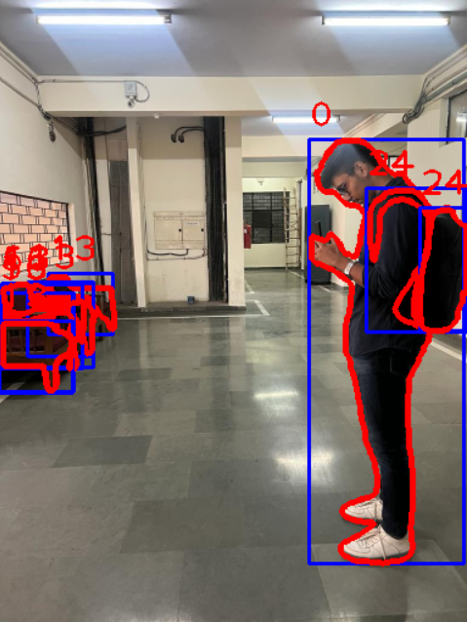

As we can see in this resulted image the model is detecting the objects and segmenting it with the red outline and also creating a blue box around the object. Model is also displaying the object class above the blue box of the object

ACCURACY

Pretrained model kikaisenikalihai sir se poochnahai

DETECTRON2

ARCHITECTURE

The detectron2 model has following components:-

1. Backbone Networks: The architecture starts with a backbone network, which is typically a convolutional neural network (CNN) pretrained on a large-scale dataset like ImageNet. Common backbones used in Detectron2 include ResNet, ResNeXt, and MobileNetV2.
2. Feature Pyramid Network (FPN):Detectron2 employs a Feature Pyramid Network to create a feature pyramid from the backbone network's output. FPN helps in handling objects at various scales, which is crucial for accurate object detection and instance segmentation.
3. Neck Modules: In addition to FPN, Detectron2 provides various neck modules that can be inserted between the backbone and the head. These modules, such as PANet and BiFPN, further enhance the feature representation for object detection tasks.
4. ROI Align or ROI Pooling: Region of Interest (ROI) Align or ROI Pooling is applied to the feature maps to extract fixed-size feature vectors for each candidate object region proposed by a Region Proposal Network (RPN). ROI Align is preferred as it offers more accurate spatial alignment compared to ROI Pooling.
5. Region Proposal Network (RPN): The RPN generates a set of candidate object regions, also known as region proposals, which are likely to contain objects. These proposals are ranked by their likelihood of containing an object, and the top proposals are selected for further processing.
6. ROI Heads: The ROI heads consist of one or more task-specific subnetworks that take the fixed-size feature vectors extracted from ROI Align/Pooling as input and produce predictions for various tasks, such as object classification and bounding box regression (for object detection) or pixel-wise segmentation (for instance segmentation). For object detection, you can have multiple ROI heads for different classes. For instance segmentation, a semantic segmentation head is added on top of the object detection head.
7. Loss Functions: Detectron2 utilizes appropriate loss functions for each task, such as the cross-entropy loss for object classification, smooth L1 loss for bounding box regression, and pixel-wise cross-entropy loss for segmentation tasks.
8. Post-processing: After the ROI heads produce predictions, post-processing steps are applied to refine and filter the results. For object detection, this often involves non-maximum suppression (NMS) to remove duplicate detections.
9. Inference and Training: Detectron2 supports both inference and training modes. During training, the model is optimized using backpropagation and gradient descent to minimize the chosen loss functions. Inference involves running a trained model on new images to make predictions.
10. Modularity and Customization: Detectron2 is designed with modularity in mind. Users can easily customize various components like backbones, necks, ROI heads, and loss functions to build models tailored to specific tasks and datasets.
11. Integration with Detectron2 Zoo: Detectron2 provides a model zoo containing pre-trained models for various computer vision tasks, making it easier for users to get started with their projects.

MODEL ZOO:

The Model Zoo offers a variety of pre-trained models. These models have been trained on large-scale, diverse datasets, using significant computational resources and expertise. They serve as a starting point for various computer vision tasks.

It is a collection of pre-trained deep learning models and associated resources specifically designed for various computer vision tasks, including but not limited to object detection, instance segmentation, keypoint detection, and image classification

All the models present in the [model zoo](https://github.com/facebookresearch/detectron2/blob/master/MODEL_ZOO.md) of the Detectron 2 library are pre-trained on COCO Dataset. We just need to fine-tune our custom dataset on the pre-trained model.

LIBRARIES AND MODULES USED:

1. detectron2.engine: This module contains the DefaultPredictor class, which is used for making predictions with a pre-trained Detectron2 model. It allows you to load a model and use it for inference.
2. detectron2.config: The get_cfg function is used to create a configuration (CfgNode) that specifies various settings for the Detectron2 model and inference process. This is where you configure model paths, dataset locations, and other parameters.
3. detectron2.utils.visualizer: The Visualizer class is used for visualizing the results of object detection. It helps draw bounding boxes and labels on images to visualize the detected objects.
4. detectron2.data: The MetadataCatalog class is used for managing metadata associated with datasets. It provides information about classes, colors, and other dataset-specific details.
5. detectron2.model_zoo: This module provides access to pre-trained models from the Detectron2 Model Zoo. You can load these models using the model_zoo.get_checkpoint_url function.
6. cv2 (OpenCV): OpenCV (Open Source Computer Vision Library) is a popular computer vision library used for various image and video processing tasks. In this code, OpenCV is used for loading and manipulating images.

NOW WE WILL SEE THE RESULT OF THE OPERATIONS ONE BY ONE WE APPLIED ON OUR IMAGES USING DETECTRON2 MODEL

1. INSTANCE SEGMENTATION

SO THIS IS OUR TESTING IMAGE WE WILL APPLY INSTANCE SEGMENTATION. USING DETECTRON2 CODE ON THIS

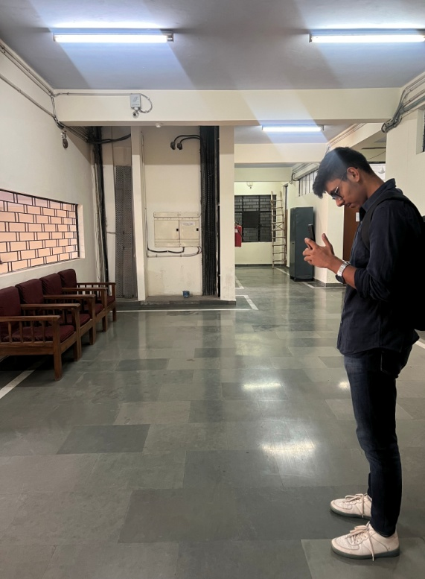

wWWE

OUTPUT

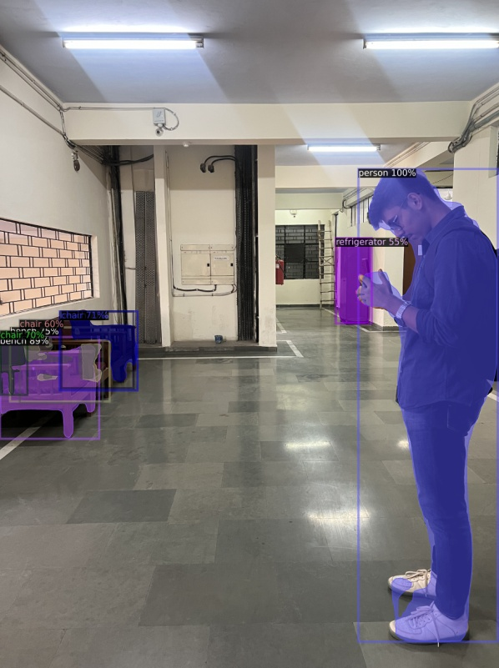

PROBLEM WITH INSTANCE SEGMENTATION

In instance segmentation it is giving us good and fast segmentation but the problem with instance segmentation is that with instance segmentation is that we can only navigate the blind person through objects with the help of this segmentation we cannot warn the blind person about the walls or the stairs as instance segmentation does not detect the walls or the stairs .we cannot get the navigable path with the help of this segmentation therefore we move to the other segmentation methods.

B) SEMANTIC SEGMENTATION

Semantic segmentation is a computer vision technique that involves the classification of each pixel in an image into a predefined category or class. Unlike object detection, which identifies and localizes objects in an image with bounding boxes, semantic segmentation assigns a label to every pixel in the image, effectively creating a pixel-wise classification map.

Semantic segmentation is a fundamental task in computer vision, and it forms the basis for various higher-level tasks like object detection, instance segmentation, and scene understanding. Advancements in deep learning have significantly improved the accuracy and efficiency of semantic segmentation models, making them essential components of many computer vision applications.

For performing semantic segmentation we have used the following models:-

1. PSPNet
2. Detectron 2

Talking about PSPNet as follows:-

PSPNet

ARCHITECTURE

PSPNet, which stands for Pyramid Scene Parsing Network, is a deep learning architecture designed for the task of semantic segmentation in images. Semantic segmentation is the process of classifying each pixel in an image into one of several predefined object classes or categories. PSPNet is known for its ability to capture both local and global context information, making it well-suited for scene parsing and understanding complex scenes in computer vision tasks.

Here are the key features and components of PSPNet:

1. **Encoder-Decoder Architecture:** PSPNet follows a standard encoder-decoder architecture commonly used in semantic segmentation models. It consists of two main parts: an encoder and a decoder.
   * **Encoder:** The encoder extracts hierarchical and progressively abstract features from the input image. It typically uses a deep convolutional neural network (CNN), often based on a pre-trained architecture like ResNet or VGG. These pre-trained networks have been trained on large datasets like ImageNet and are capable of capturing rich visual features.
   * **Decoder:** The decoder takes the feature maps produced by the encoder and upsamples them to the original image resolution. It also incorporates skip connections to combine feature maps from multiple scales, enhancing the model's ability to capture fine-grained details.
2. **Pyramid Pooling Module (PPM):** The key innovation in PSPNet is the Pyramid Pooling Module. Instead of applying a single fixed-size pooling operation (e.g., max-pooling or average-pooling), PSPNet performs pooling at multiple spatial scales. This module captures both local and global context information. The output of the Pyramid Pooling Module is a set of feature maps, each encoding context information at a different scale.
3. **Skip Connections:** PSPNet incorporates skip connections that connect feature maps at different levels of the encoder to the corresponding levels in the decoder. This allows the model to combine low-level and high-level features, helping to improve segmentation accuracy.
4. **Final Classification:**  The output of the decoder is typically passed through a softmax activation function to produce pixel-wise class probabilities. Each pixel is assigned a class label based on the class with the highest probability.
5. **Training:** PSPNet is trained using labeled training data where each pixel in the image has a ground-truth class label. The model is trained to minimize a suitable loss function, such as cross-entropy loss, which measures the difference between predicted class probabilities and ground-truth labels.

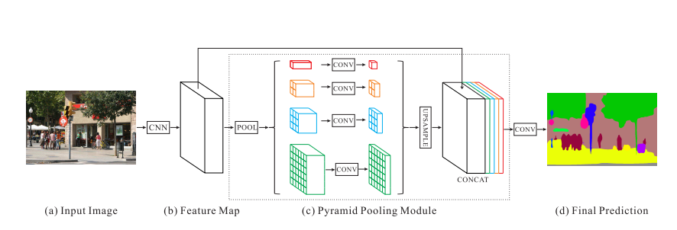

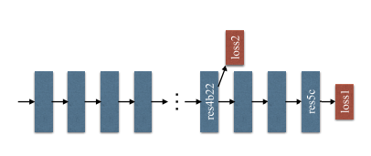

PSPNet has been widely used in various computer vision applications, including scene parsing, autonomous driving, and medical image analysis, due to its ability to handle complex scenes and produce detailed semantic segmentation maps.

DATASET

The ADE20K dataset, short for "ADE20K Scene Parsing," is a large-scale and diverse dataset designed for the task of semantic segmentation and scene parsing in computer vision. It is commonly used for training and evaluating deep learning models, particularly those used in image segmentation and scene understanding. The dataset is known for its extensive scene categories and object classes, making it suitable for a wide range of applications, including image parsing, object recognition, and scene understanding.

Here's some key information about the ADE20K dataset:

1. **Dataset Size:** ADE20K is a substantial dataset, consisting of over 20,000 images. These images cover a diverse range of indoor and outdoor scenes, captured under various lighting and environmental conditions.
2. **Scene Categories:** ADE20K includes images from 150 different scene categories. These categories encompass a wide variety of scenes, such as bedrooms, offices, streets, parks, kitchens, forests, and more. This diversity is crucial for training models to understand and segment scenes effectively.
3. **Object Classes:** In addition to scene categories, the dataset provides detailed annotations for object classes within each scene. These object classes include various everyday objects, furniture, vehicles, and other elements that appear in scenes. The detailed object-level annotations enable fine-grained scene parsing.
4. **Pixel-Level Annotations:** ADE20K provides pixel-wise annotations for semantic segmentation. Each pixel in the images is labeled with a class ID corresponding to the scene category or object class it belongs to. This level of detail makes ADE20K valuable for training and evaluating models that perform pixel-level image segmentation.
5. **Challenges:** The dataset contains some challenging aspects, such as occlusions, object variations, and complex scenes, which make it suitable for testing the robustness and generalization of segmentation algorithms.
6. **Usage:** ADE20K is commonly used for training and benchmarking deep learning models, particularly convolutional neural networks (CNNs), for tasks like semantic segmentation, scene parsing, and object recognition. Researchers and practitioners in computer vision use ADE20K to develop and evaluate state-of-the-art segmentation algorithms.
7. **Evaluation:** Common evaluation metrics used with ADE20K include pixel-wise accuracy, mean intersection over union (mIoU), and class-wise IoU. These metrics help assess the performance of segmentation models on this dataset.

ADE20K has contributed significantly to the advancement of semantic segmentation and scene parsing research, as it provides a comprehensive and challenging dataset for training and evaluating models. Researchers have developed various deep learning architectures and techniques using ADE20K as a benchmark, pushing the boundaries of what is achievable in scene understanding and pixel-level segmentation tasks.

LIBRARIES USED

1. **opencv-python:**
   * Description: OpenCV is an open-source computer vision library that provides tools for image processing, computer vision, and machine learning. The opencv-python package is a Python wrapper for the OpenCV library, making it easy to use OpenCV functions in Python scripts.
2. **Keras:**
   * Description: Keras is a high-level deep learning API that simplifies the process of building and training neural networks. It provides a user-friendly and modular interface for creating deep learning models. Keras can be used with various backend engines, including TensorFlow and Theano.
3. **Tensorflow:**
   * Description: TensorFlow is an open-source machine learning framework developed by Google. It is widely used for building and training deep neural networks. TensorFlow offers a flexible and scalable platform for various machine learning tasks, including image recognition, natural language processing, and more.
4. **keras-segmentation:**
   * Description: keras-segmentation is a library that provides pre-trained semantic segmentation models and tools for semantic segmentation tasks. It simplifies the process of working with semantic segmentation models like PSPNet, U-Net, and more, using the Keras deep learning framework.
5. **numpy:**
   * Description: NumPy is a fundamental library for scientific computing in Python. It provides support for multidimensional arrays, along with a wide range of mathematical functions to operate on these arrays. NumPy is a fundamental tool for data manipulation in many scientific and machine learning applications.
6. **matplotlib.pyplot:**
   * Description: Matplotlib is a widely used Python library for creating static, animated, and interactive visualizations in data science and machine learning projects. matplotlib.pyplot is a module within Matplotlib that provides a simple interface for creating plots, charts, and other data visualizations.
7. **PIL (Python Imaging Library) or Pillow:**
   * Description: PIL (Python Imaging Library) is a library for opening, manipulating, and saving many different image file formats. However, PIL is no longer actively maintained. Pillow is a modern, more actively maintained fork of PIL, and it serves the same purpose, making it easy to work with images in Python scripts and applications.

RESULT

Here in the figure shown below the left side is the input image and in right side is the black image whereas the white part represents the navigable path.

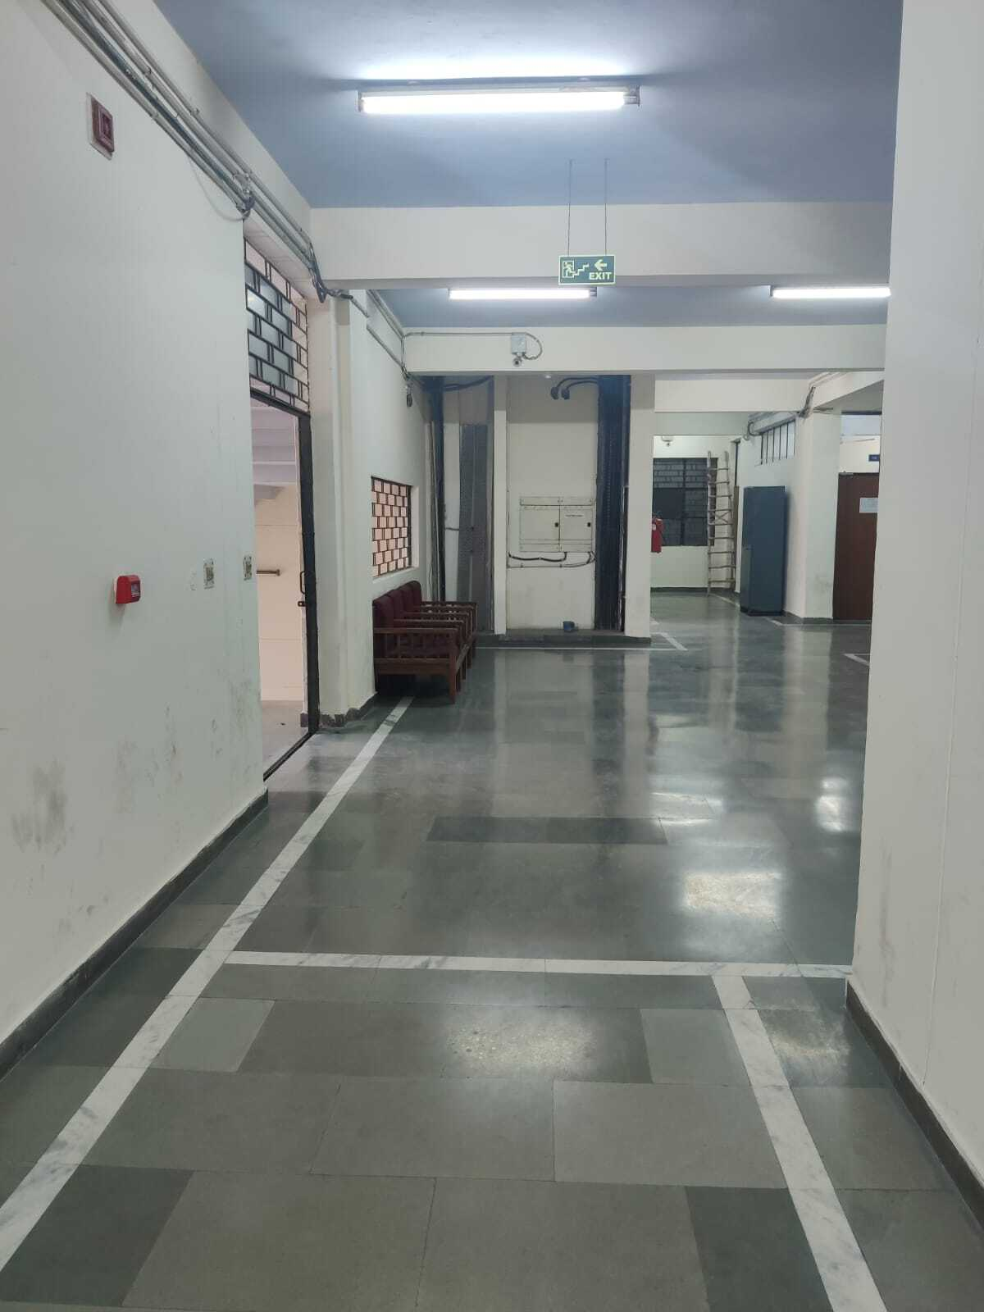

ACCURACY

PROBLEMS FACED IN SEMANTIC SEGMENTATION

Here are some common issues and challenges associated with semantic segmentation:

1. Fine-Grained Object Boundaries: Accurately delineating object boundaries, especially for objects with intricate shapes or fine details, can be challenging. Models may produce jagged or imprecise boundaries, leading to segmentation errors.
2. Class Imbalance: In many datasets, some object classes are rare compared to others. Class imbalance can lead to biases in the model, causing it to perform poorly on underrepresented classes.
3. Ambiguity and Overlapping Objects: When objects overlap or are partially occluded, determining the exact boundaries and class labels of each object can be challenging. Models may struggle to handle such situations accurately.
4. Scale Variability: Objects in an image can vary significantly in size, and models need to be capable of detecting and segmenting both small and large objects effectively. Real-
5. Time Processing: Achieving real-time or near-real-time performance in applications like autonomous driving or robotics can be demanding in terms of model complexity and computational resources.
6. Memory and Computational Resources: Semantic segmentation models often require substantial computational resources, including GPU memory and processing power, making them less accessible for resource-constrained environments.

C) PANOPTIC SEGMENTATION

Panoptic segmentation is a computer vision task that combines two important subtasks: semantic segmentation and instance segmentation. It aims to provide a comprehensive understanding of an image by simultaneously segmenting all objects and stuff (background regions) into distinct categories and identifying individual instances of objects. In essence, it unifies the semantic and instance segmentation tasks to provide a more holistic scene understanding.

Thus it's main components are two as follows:-

(a) Semantic Segmentation: In the context of panoptic segmentation, semantic segmentation refers to the pixel-wise classification of objects and stuff in an image. Each pixel is assigned a class label, where objects of the same category share the same label. For example, all pixels belonging to "cars" will have the same label.

(b) Instance Segmentation: Instance segmentation, on the other hand, goes a step further by distinguishing individual instances of objects within the same category. This means that not only are objects classified (semantic segmentation), but unique identifiers are assigned to different instances of objects. For example, it can differentiate between two different cars in the image.

For performing panoptic segmentation we use the Detectron2 model.

DETECTRON2

ARCHITECTURE

The detectron2 model has following components:-

1. Backbone Networks: The architecture starts with a backbone network, which is typically a convolutional neural network (CNN) pretrained on a large-scale dataset like ImageNet. Common backbones used in Detectron2 include ResNet, ResNeXt, and MobileNetV2.
2. Feature Pyramid Network (FPN):Detectron2 employs a Feature Pyramid Network to create a feature pyramid from the backbone network's output. FPN helps in handling objects at various scales, which is crucial for accurate object detection and instance segmentation.
3. Neck Modules: In addition to FPN, Detectron2 provides various neck modules that can be inserted between the backbone and the head. These modules, such as PANet and BiFPN, further enhance the feature representation for object detection tasks.
4. ROI Align or ROI Pooling: Region of Interest (ROI) Align or ROI Pooling is applied to the feature maps to extract fixed-size feature vectors for each candidate object region proposed by a Region Proposal Network (RPN). ROI Align is preferred as it offers more accurate spatial alignment compared to ROI Pooling.
5. Region Proposal Network (RPN): The RPN generates a set of candidate object regions, also known as region proposals, which are likely to contain objects. These proposals are ranked by their likelihood of containing an object, and the top proposals are selected for further processing.
6. ROI Heads: The ROI heads consist of one or more task-specific subnetworks that take the fixed-size feature vectors extracted from ROI Align/Pooling as input and produce predictions for various tasks, such as object classification and bounding box regression (for object detection) or pixel-wise segmentation (for instance segmentation). For object detection, you can have multiple ROI heads for different classes. For instance segmentation, a semantic segmentation head is added on top of the object detection head.
7. Loss Functions: Detectron2 utilizes appropriate loss functions for each task, such as the cross-entropy loss for object classification, smooth L1 loss for bounding box regression, and pixel-wise cross-entropy loss for segmentation tasks.
8. Post-processing: After the ROI heads produce predictions, post-processing steps are applied to refine and filter the results. For object detection, this often involves non-maximum suppression (NMS) to remove duplicate detections.
9. Inference and Training: Detectron2 supports both inference and training modes. During training, the model is optimized using backpropagation and gradient descent to minimize the chosen loss functions. Inference involves running a trained model on new images to make predictions.
10. Modularity and Customization: Detectron2 is designed with modularity in mind. Users can easily customize various components like backbones, necks, ROI heads, and loss functions to build models tailored to specific tasks and datasets.
11. Integration with Detectron2 Zoo: Detectron2 provides a model zoo containing pre-trained models for various computer vision tasks, making it easier for users to get started with their projects.

MODEL ZOO:

The Model Zoo offers a variety of pre-trained models. These models have been trained on large-scale, diverse datasets, using significant computational resources and expertise. They serve as a starting point for various computer vision tasks.

It is a collection of pre-trained deep learning models and associated resources specifically designed for various computer vision tasks, including but not limited to object detection, instance segmentation, keypoint detection, and image classification

All the models present in the [model zoo](https://github.com/facebookresearch/detectron2/blob/master/MODEL_ZOO.md) of the Detectron 2 library are pre-trained on COCO Dataset. We just need to fine-tune our custom dataset on the pre-trained model.

LIBRARIES AND MODULES USED:

1. detectron2.engine: This module contains the DefaultPredictor class, which is used for making predictions with a pre-trained Detectron2 model. It allows you to load a model and use it for inference.
2. detectron2.config: The get_cfg function is used to create a configuration (CfgNode) that specifies various settings for the Detectron2 model and inference process. This is where you configure model paths, dataset locations, and other parameters.
3. detectron2.utils.visualizer: The Visualizer class is used for visualizing the results of object detection. It helps draw bounding boxes and labels on images to visualize the detected objects.
4. detectron2.data: The MetadataCatalog class is used for managing metadata associated with datasets. It provides information about classes, colors, and other dataset-specific details.
5. detectron2.model_zoo: This module provides access to pre-trained models from the Detectron2 Model Zoo. You can load these models using the model_zoo.get_checkpoint_url function.
6. cv2 (OpenCV): OpenCV (Open Source Computer Vision Library) is a popular computer vision library used for various image and video processing tasks. In this code, OpenCV is used for loading and manipulating images.

NOW WE WILL SEE THE RESULT OF THE OPERATIONS ONE BY ONE WE APPLIED ON OUR IMAGES USING DETECTRON2 MODEL

# PANOPTIC SEGMENTATION:

Here is the output for panoptic segmentation.

OUTPUT-

OUTPUT: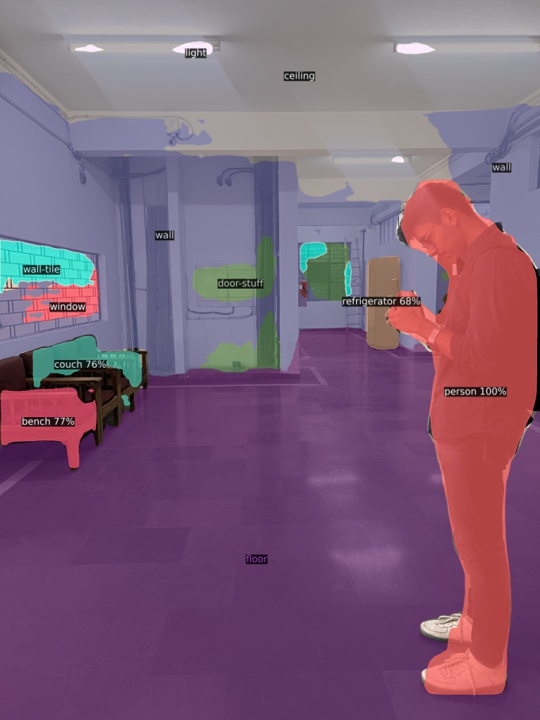

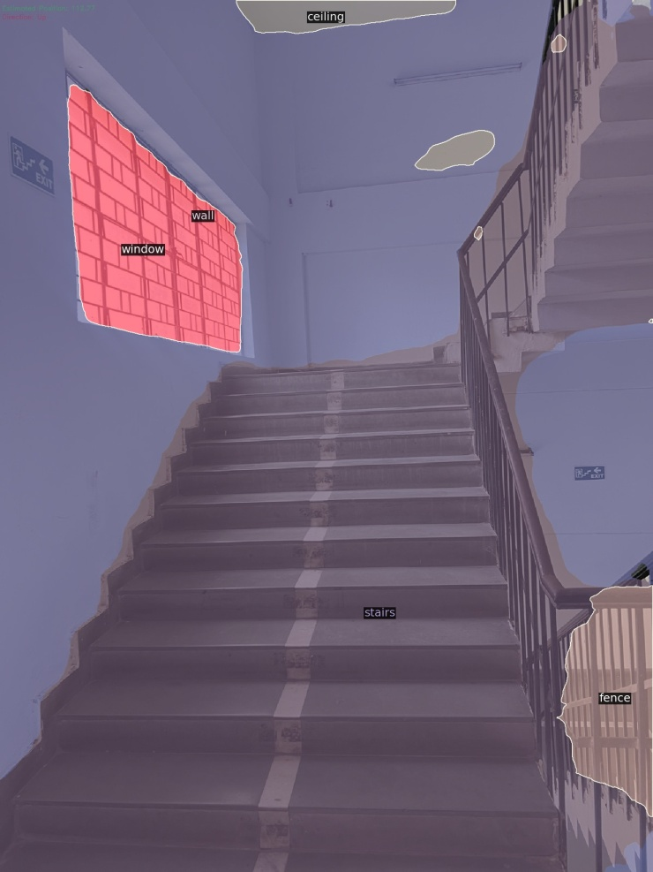

As here we can see we are getting great accuracy panoptic segmentation result on our testing image with labels showcasing the name of the object and accuracy level of the labels ,and we getting the output image combination of instance + semantic segmentation ,so it is segmenting the whole image .

WHY IT IS BEST FOR OUR PROJECT??

Reason: In instance segmentation we are only getting detection of the objects in our testing image but in panoptic segmentation we are getting the whole detection of the image even the floor and stairs so for this project we need both detection of the objects and floor or stairs…. so we can provide the clear view and great navigation to the blind person using this segmentation.

ADVANTAGES OF USING PANOPTIC SEGMENTATION

The best suited segmentation is panoptic segmentation as it provides the best results. Now here are some advantages listed of ponaoptic segmentation:-

(a)Holistic Scene Understanding: Panoptic segmentation provides a comprehensive and holistic understanding of visual scenes by simultaneously segmenting both objects (things) and stuff (background regions). This enables a deeper understanding of the entire scene, including objects, their interactions, and the context in which they exist.

(b)Object-Level and Pixel-Level Detail: It offers both object-level information, where individual instances of objects are identified and differentiated, and pixel-level information, where each pixel is assigned a semantic label. This dual-level detail is valuable for various tasks, from tracking objects to analyzing scene semantics.

(c)Enhanced Context Awareness: Panoptic segmentation enhances context awareness by distinguishing between objects and background elements. This distinction is crucial for context-aware decision-making, particularly in applications like autonomous driving and robotics, where understanding the environment is essential.

(d)Unified Data Representation: It provides a unified representation of an image, combining semantic labels and instance IDs. This unified representation simplifies data handling and interpretation, making it easier to process and use the segmented information for downstream tasks and applications

METHODOLOGY USED

TARGET - PATH NAVIGATION

1. AVERAGE DEPTH ESTIMATION
2. GRID

Studying about them in detail:-

1. AVERAGE DEPTH ESTIMATION

Depth estimation or extraction feature is nothing but the techniques and algorithms which aims to obtain a representation of the spatial structure of a scene. In simpler words, it is used to calculate the distance between two objects. Our prototype is used to assist the blind people which aims to issue warning to the blind people about the hurdles coming on their way. In order to do this, we need to find that at how much distance the obstacle and person are located in any real time situation. After the object is detected rectangular box is generated around that object.

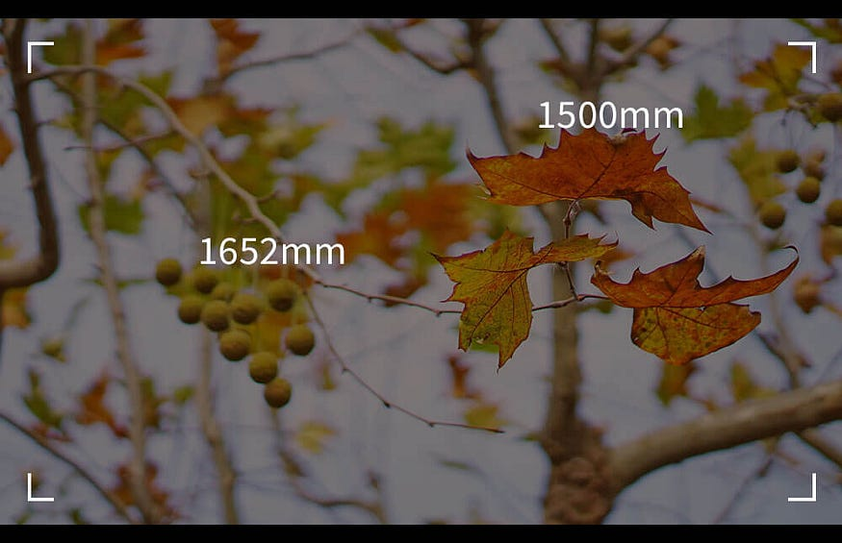

Distance Approximations

If that object occupies most of the frame then with respect to some constraints the approximate distance of the object from the particular person is calculated. Following code is used to recognize objects and to return the information of the distance and location.

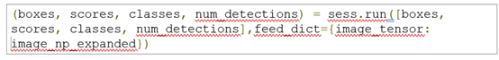

Here, we have established a Tensorflow session comprised of Crucial Features for Detection. So, for further analysis iteration is done through the boxes. Boxes are an array, inside of an array. So, for iteration we need to define the following conditions.

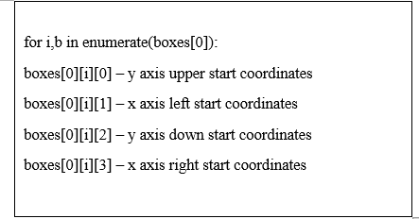

Index of box in boxes array is represented by i. Analysis of the score of the box is done by index. It is also used to access class. Now the width of the detected object is measured. This is done by asking the width of an object in terms of pixels.

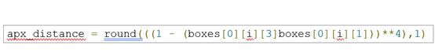

We got the center of two by subtracting the same axis start coordinates and dividing them by two. In this way the centre of our detected rectangle is calculated. And at the last, a dot is drawn in the centre. The default parameter for drawing boxes is a score of 0.5. if scores[0][i] >= 0.5 (i.e. equal or more than 50 percent) then we assume that the object is detected. if scores[0][i] >= 0.5:

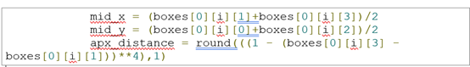

In the above formula, mid_x is centre of X axis and mid_y is centre of y axis. If the distance apx_distance< 0.5 and if mid_x> 0.3 and mid_x< 0.7 then it can be concluded that the object is too close from the particular person. With this code, relative distance of the object from a particular person can be calculated. After the detection of object the code is used to determine the relative distance of the object from the person. If the object is too close then signal or a warning is issued to the person through voice generation module.

1. PROXIMITY GRID METHOD

Proximity grid method just a simple technique in which we just seprates the navigable path from the rest of the segmentation like this

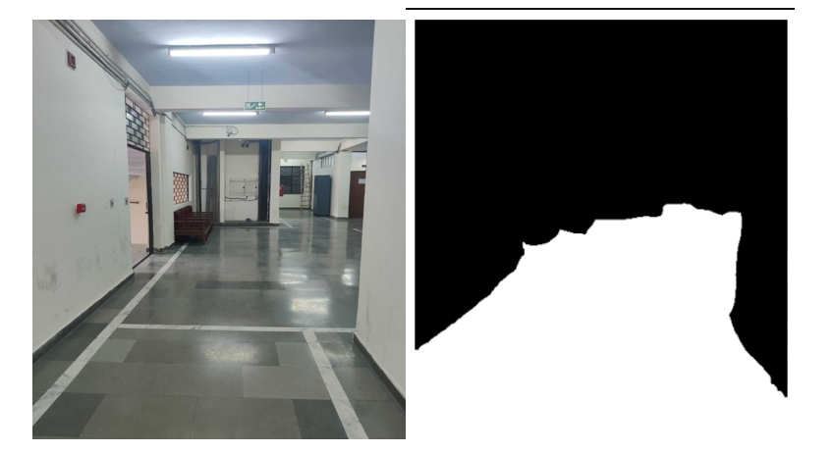

And after this separation we make a simple grid in the bottom center of the frame and check if anything else come in the grid other than the navigable mask.

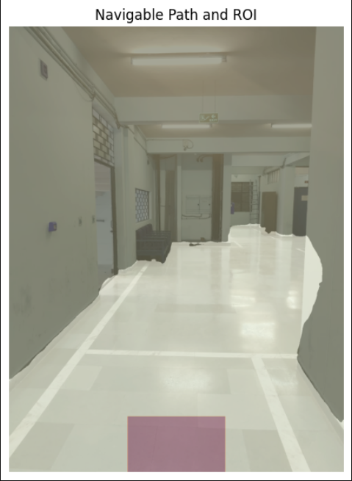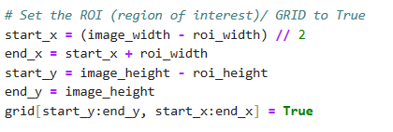

First figure shows the bottom grid and the navigable mask Second figure shows the making of the grid

 So this is how we are checking if there is any non navigable pixel in the grid and returning true if there is any non navigable pixel is present in the grid and accordingly direct the person where to move and warning to him about the object .  
  
This is a simple based on the assumption that the anything that comes in the bottom center of the frame is close to object and the person is to be warned about it and directed accordingly

STAIRCASE DETECTION

OVERVIEW:

Here we are determining the predominant direction of a staircase whether its going up or down . this uses computer vision technique such as hough transform , to analyse the image and calculate the mean orientation of detected lines.based on this orientation,it classifies the staircase direction as “up” or “down” and annotates the image accordingly.

Canny’s edge detection:the canny edge detection algorithm is used to identify edges in the image. it identify the edges within the grayscale image which is very useful for our next step such as line detection using hough transform.

Line detection (hough transform): it is a fundamental computer vision task aimed at identifying straight lines or line segments within an image. it is a technique used to detect shapes,particularly lines in an image.it works by representing lines in a space called hough space, where each line in the image corresponds to a point in this space.

Direction classification: for each detected line ,it calculates the orientation angle using trigonometric functions. a threshold angle of 45 degrees is defined to classify the direction of the staircase. if the mean orientation agle is less than threshold angle,the direction is classifies as “up” otherwise it is classifies as “down”.

LIBRARIES USED

1. opencv: it plays a pivot role in image processing and manipulation tasks ,making it an essential livrary for the successful execution of staircase direction detection it performs the following important tasks in our staircase detection

2. gaussian blur(noise reduction): the library applies this to the grayscale image,reducing noise because it is necessary for accurate edge detection.

3. edge detection: opencv’s canny edge detection

4. line detection: we apply opencv’s hough transform function for identifying staircase orientation.

5. text annotation and displaying the image:opencv’s puttext function is used to annotate the image with the determined staircase direction.and in the last displaying the image.

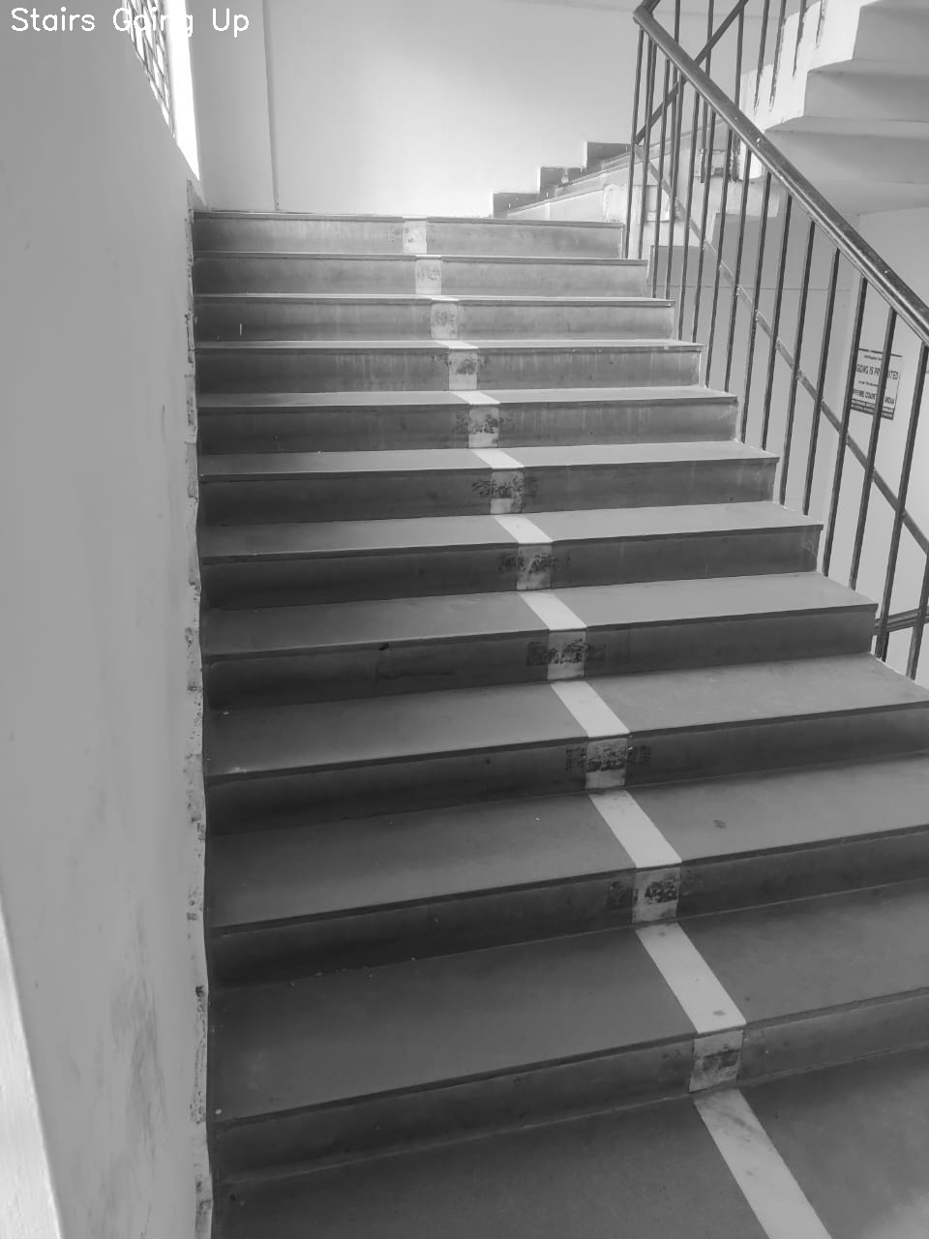OUTPUT :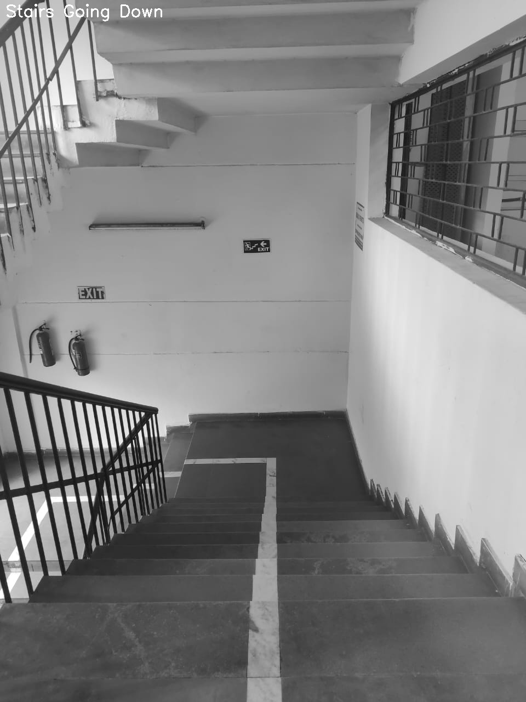

When we apply this code on video we used one thing more

k-means clustering

It gorups similar things together .in this case,it groups similar angles together. after detecting lines,we have a list of angles . So k-means groups these angles into categories,like putting similar colours together , its like sorting colours to see patterns . This helps us to tell if the stairs is going iup or down more accurately by looking at angles in a very smarter way.

RESULTS

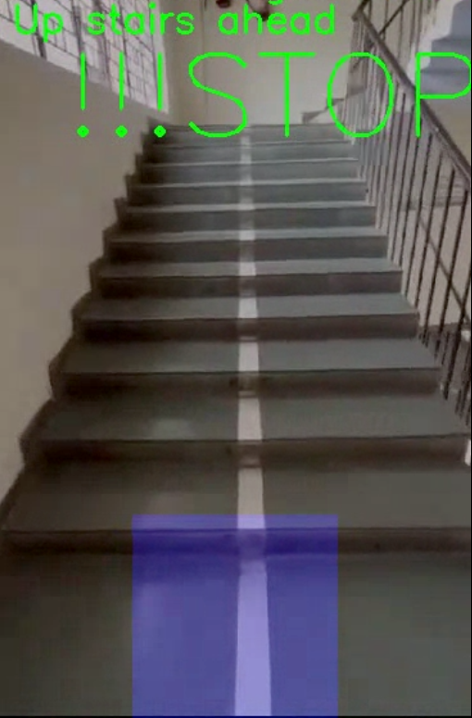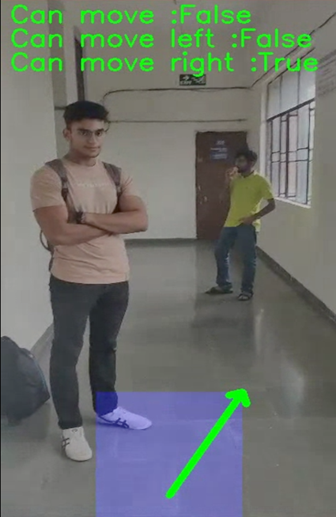The final results of the project are to help the blind person navigate its surrounding easily and safely that it guide the blind person where to move on the baisis of the objects in front and if there is any navigable path ahead and also if there are stairs ahead that to if they are going up or down 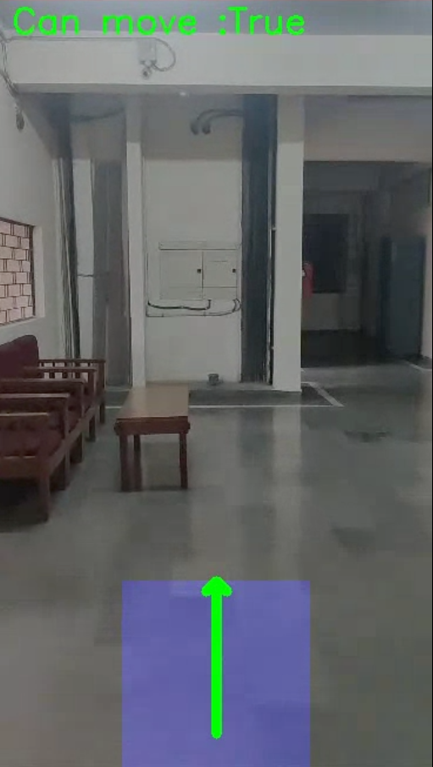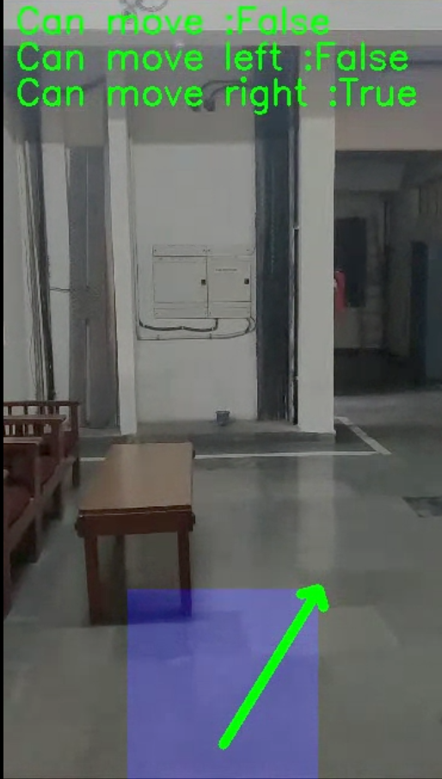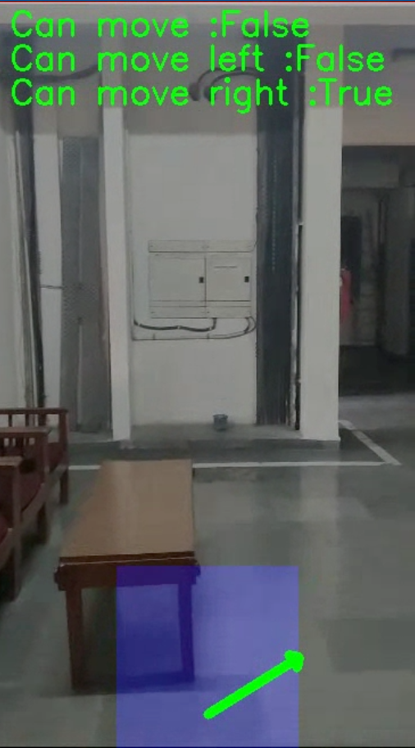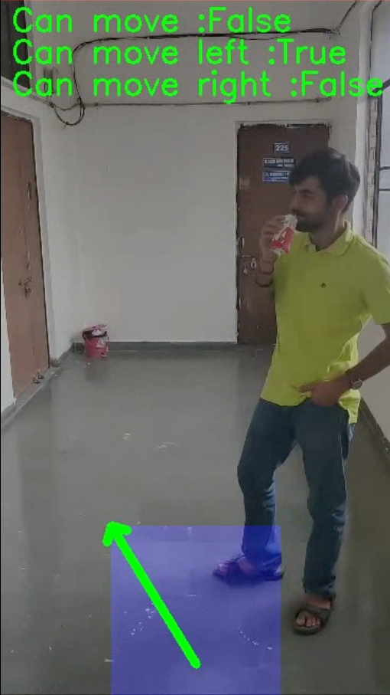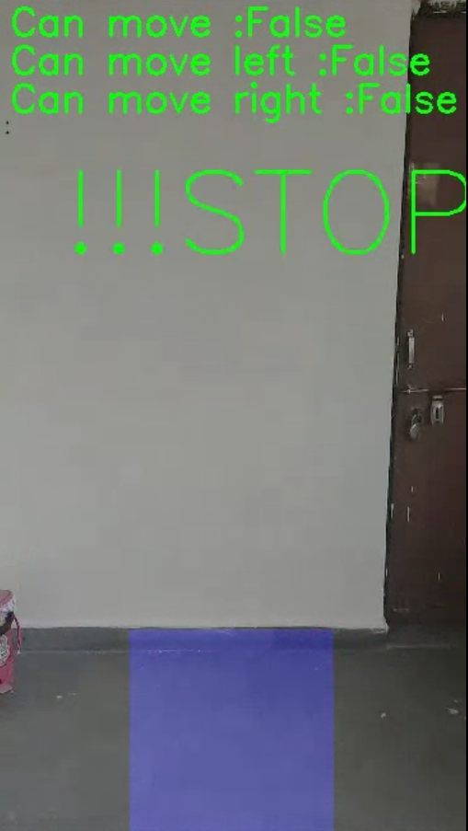

FUTURE OF PROJECT

1. One of the future aspects of the project is that it can provide the client the facility to be guided using the voice feedback mechanism. This voice feedback mechanism helps the visually impaired person to navigate easily through the obstacle course. It mainly consists of 3 parts:-

(a) Text-to-Speech (TTS) Engine:

Choose a reliable TTS engine that can convert text into natural-sounding speech. Some popular options include Google Text-to-Speech, Amazon Polly, or open-source libraries like eSpeak or pyttsx3 for Python.

(b) Speech Recognition (ASR):

Consider incorporating Automatic Speech Recognition (ASR) to enable voice commands or interactions with the system. This allows users to give voice input to the system, enhancing the user experience.

(c)Navigation Instructions:

Provide clear and concise navigation instructions. For example, the system can inform the user about nearby obstacles, directions to specific locations, distance to objects, and nearby landmarks.

This is one aspect on which in future we can build the project further.

(2) One of the very important discussions about this project is that is it available to the needy?? It can obviously used and accessed by the elite class people but the people who cannot afford it are the ones who actually need to be feeeded using this. So the other next two points are regarding this feature.

(a) Accessibility Standards Compliance:

Ensure that the blind assistance systems adhere to the latest accessibility standards and guidelines, including WCAG, to guarantee usability for individuals with disabilities.

(b)Afordability and Accessibility:

Focus on making blind assistance technology more affordable and widely accessible, particularly in developing regions.

(3) The third and the most important feature that will help this project grow worldwide is the user feedback. Feedback is something that always encourages the user to modify and improve the mechanism he/she has developed.

User Feedback and Involvement:

Continuously involve visually impaired individuals in the development process, gather feedback, and incorporate user suggestions for improvements.

(4) At a point to increase the awareness regarding this tool obviously we need to reach out maximum people that can only happen using government involvement and integration with private and public sctor companies.

(a) Integration with Smart Cities:

Collaborate with smart city initiatives to ensure that blind assistance systems can seamlessly integrate with urban infrastructure and services.

(b) Education and Training:

Offer training and educational resources to help users maximize the benefits of blind assistance systems and stay up-to-date with new features.

CONCLUSION

In conclusion our blind assisstance project holds immense promise for improving the lives of visually impaired by enhancing their independence, mobility, and overall quality of life. This project deals with technologies and innovative solutions to address the unique challenges faced by individuals with visual impairments.

ISme ek ka mujhe ek baat sir se puchni hai

REFERENCES

NOW WE WILL SEE THE RESULT OF THE OPERATIONS ONE BY ONE WE APPLIED ON OUR IMAGES USING DETECTRON2 MODEL

1. INSTANCE SEGMENTATION

SO THIS IS OUR TESTING IMAGE WE WILL APPLY INSTANCE SEGMENTATION. USING DETECTRON2 CODE ON THIS